Tomcat支持的四种线程模型

----图灵学院

NIO是网络编程的基础。

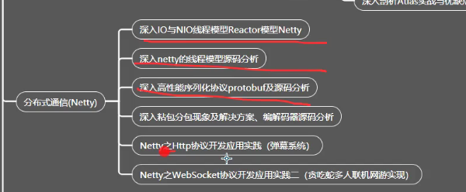

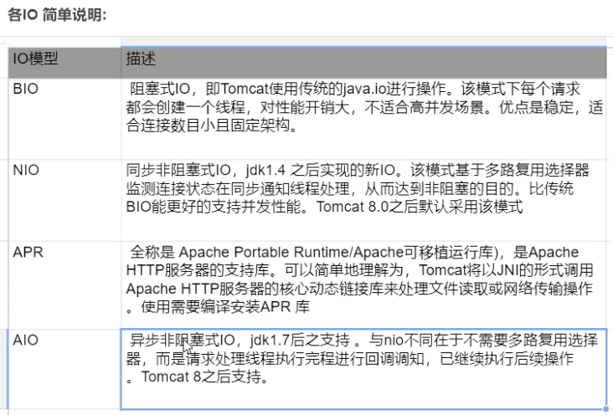

Tomcat的配置: server.xml中修改。

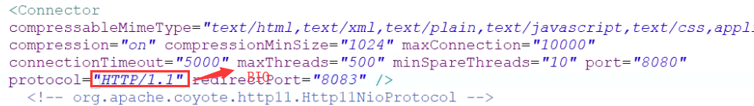

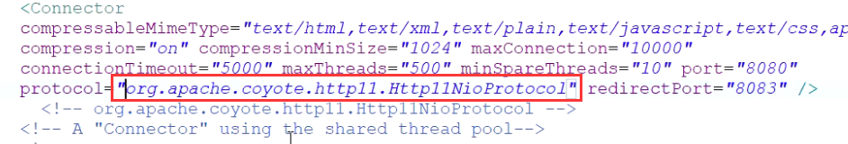

**[http-nio-8080]**

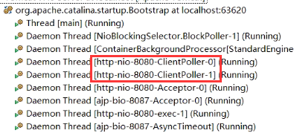

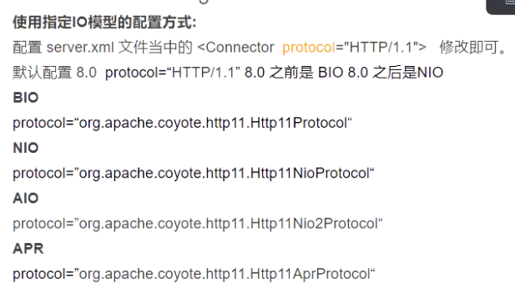

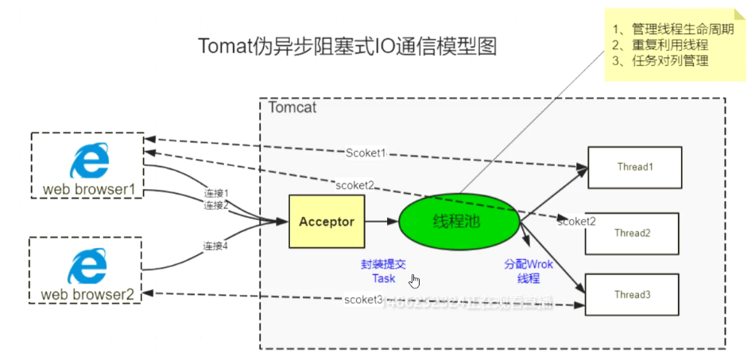

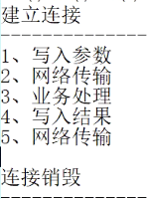

Tomcat源码分析:

Acceptor类：实现了Runnable接口：

Acceptor线程只有一个，相当于唯一的一个门卫，所有的请求都需要通过Acceptor接收。

// Loop until we receive a shutdown command  
while (endpoint.isRunning()) {  
 // Loop if endpoint is paused  
 while (endpoint.isPaused() && endpoint.isRunning()) {  
 state = AcceptorState.*PAUSED*;  
 try {  
 Thread.*sleep*(50);  
 } catch (InterruptedException e) {  
 // Ignore  
 }  
 }  
 if (!endpoint.isRunning()) {  
 break;  
 }  
 state = AcceptorState.*RUNNING*;  
 try {  
 //if we have reached max connections, wait  
 endpoint.countUpOrAwaitConnection();  
 // Endpoint might have been paused while waiting for latch  
 // If that is the case, don't accept new connections  
 if (endpoint.isPaused()) {  
 continue;  
 }  
 U socket = null;  
 try {  
 **// Accept the next incoming connection from the server  
 // socket  
 socket = endpoint.serverSocketAccept();**  
 } catch (Exception ioe) {……

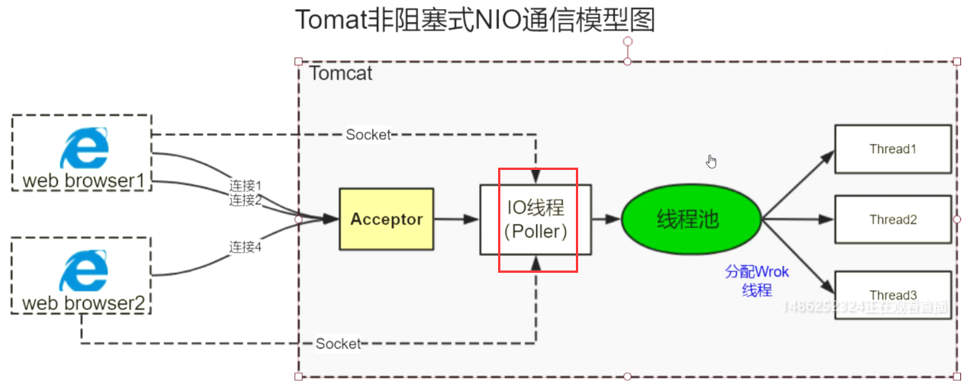

NIO中的原理：多了Poller线程，Poller线程相当于产品经理的作用；

Selector

Tomcat8.0中的BIO已经过时了。

